## **Adventure Guild GDD and To-Do List**

*Run a guild of adventurers while growing your own heroic renown!*

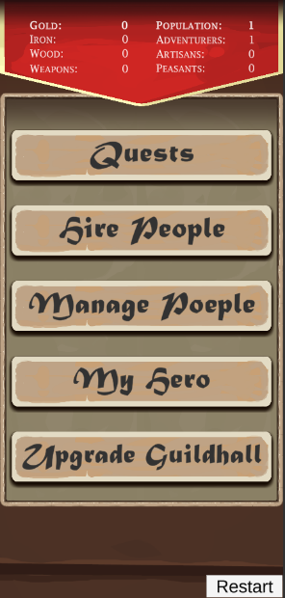 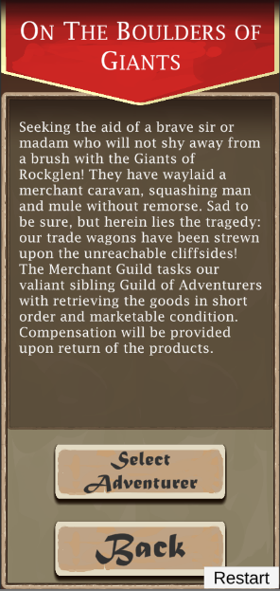 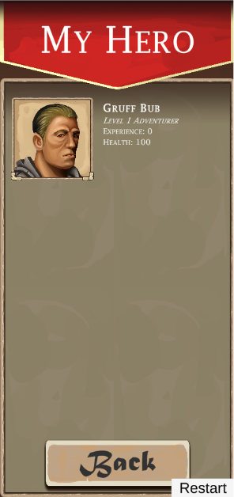

**Genre:** Menu based / Management / Single player  
**Target Audience:** Rated E (or T, depending on quests)

**Controls:** Touch screen

**Thematic Setting:** Medieval Fantasy / Knights & Monsters / Magic

**Tech Stack:** Unity 2019.4, Asset Store for UI assets, Assets for SFX and music

**Platform(s):** Google Play Store, iOS Store

**MVP Game Moment:** Sending your hero on a quest and reading the incidental updates until they return and claim their reward! (1 minute)

**Game Summary:** Adventure Guild places the player in the role of managing a guild of adventurers. Create your Hero and send them on adventures for fame and riches. Slowly more adventurers will join you and more quests can be undertaken. Each quest is timed, the more challenging ones requiring higher level adventurers, more time, and even special skills. Collect resources on the quests to upgrade the Guildhall and unlock even more amazing quests.

**Core Player Experience:** Menu based management sim

**Central Story Theme:** Hero gains renown and builds an adventuring guild with many NPC members.

**Design Pillar:** Play at work, little time commitment.

**Remarkability:** Engaging quests and addictive loop.

**Anticipated Steam Early Access Launch date:** Holiday 2020

**Feature Development Priorities (To-Do):**

* Quest time
* Rewards
* Persistent data

**Additional Tasks:**

* Create more quests
* Create more adventurer names
* Create and implement incidental events
* Skill system for adventurers